Conducted Immunity Test Report

Contents

1. Test lab facility 2

Test Site: 2

Facility name: 2

Facility address: 2

Facility site description: 2

Test Standards 2

EMC Directive 2014/30/EU 2

Test Equipment: 2

Environmental conditions: 3

Test Operator and Date: 3

2. Product Information 3

3. EUT setup 3

Photograph of EUT: 4

4. Test Result 5

5. Summary 11

# Test lab facility

## Test Site:

Facility name: Keysight Technology, Technology Order Fulfillment, Colorado Springs Hardware Test Center.

Facility address: 1900 Garden of the Gods Rd, Colorado Springs, CO. 80907

Facility site description:

The Keysight Technologies Technology Order Fulfillment Colorado Spring Hardware Test Center is a certified radiated interference testing facility, which is comply with the standard requirements defined by IEC 61326.

## Test Standards

### EMC Directive 2014/30/EU

IEC 61326-1:2012 / EN 61326-1:2013 (Basic)

Radiated Immunity Reference Standards:

IEC 61000-4-3:2016 Group 1 Class A.

The products were tested in a typical configuration with Keysight Technologies test systems. This product is intended for use in a basic electromagnetic environment.

## Test Equipment:

|  |  |
| --- | --- |
| Power Sensor Address (Low Band) | USB0::0x0957::0x2D18::MY47400241::0::INSTR |
| Power Sensor Address(High Band) | USB0::0x0957::0x2D18::MY55500012::0::INSTR |
| Signal Generator Address | GPIB0::19::INSTR |
| RF Switch Com Port | COM6 |
| Power Amplifier Address(High Band) | GPIB0::2::INSTR |
| Turn Table Address | GPIB0::8::INSTR |
| Antenna Tower Address | GPIB0::9::INSTR |
| Field Probe Address (optional) | COM7 |
| Calibration File | ./configuration/RI_Coefficients_300pints_newbox_newcable.mat |
| USB power meter 1 Lower Band | Model: U2004A Calibration date: 8/5/2017 |
| USB power meter 2 Higher Band | Model: U2004A Calibration date: 8/5/2017 |
| Signal Generator SN | Model: N5181A Calibration Data12/1/2017 |
| Test Standard | IEC 61000-4-6 / EN 61000-4-6 Basic 80MHz-6GHz: 3V/M |
| Test Site | Colorado Springs TOF Hardware Test Center |
| Test Voltage | 110V |
| Test Software Version | V1.5 |

## Environmental conditions:

Temperature: 72°F; Humidity :50 RH

Note: There will be no effect to the result due to changes in mains voltage or frequency.

## Test Operator and Date:

Operator: Clifford; Report generated at: Apr.26,2018 9:08:56 AM

# Product Information

|  |  |
| --- | --- |
| Product Name: | Gmax |
| Product Model: | DSOX1204G |
| Product SN: | CN58027110 |
| Project Stage: | PP-33 |
| Deliver date of the test samples: | 4/25//2018 |
| DUT power: | 110V |
| Auxiliary equipment list: | Cables BNC LAN |
| Model numbers covered by the test: | N/a |
| .-Hardware Difference | N/a |
| .-Software/firmware difference: | N/a |
| .-Cosmetic difference: | NA |
| Test Configuration | maximum acq mode all 4 chs on. |
| Test Software Version | V1.5 |

# EUT setup

Radiated Immunity Test Setup- Table-Top and Control Room

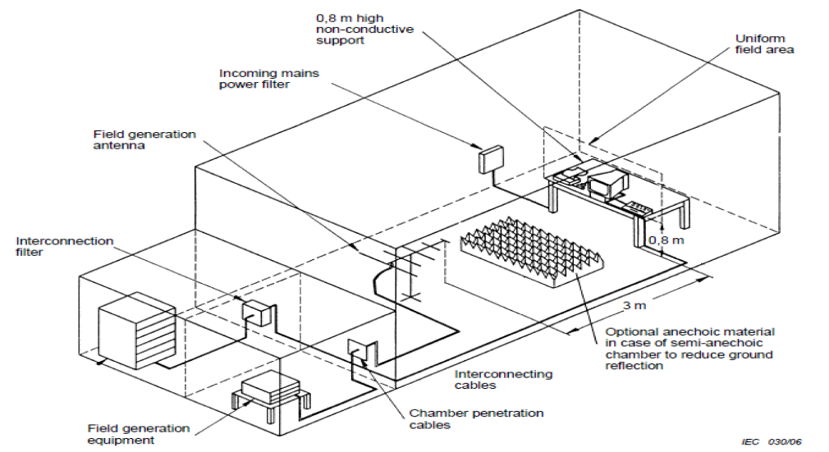

## Photograph of EUT:

# Test Result

**Test Parameters:**

Frequency 80 MHz - 6 GHz; 80% Amplitude Modulated at 1 KHz

Sweep Rate 2.5 Seconds dwell per 1% step, 1.73E-03 Decades per Second

Filed Strength 3 v/m

Polarity Horizontal and Vertical

Rotation Front (0°) Left (90° ) Rear (180°) and Right (270°)

|  |  |  |  |
| --- | --- | --- | --- |
| Frequency (MHz) | DUT Pos. | Antenna Pos. | Remark |
| 80 | Front | Horizontal/Vertical | A. Pass -Normal performance within specified limits |
| 6000 | Front | Horizontal/Vertical | A. Pass -Normal performance within specified limits |
| 80 | Right | Horizontal/Vertical | A. Pass -Normal performance within specified limits |
| 6000 | Right | Horizontal/Vertical | A. Pass -Normal performance within specified limits |
| 80 | Rear | Horizontal/Vertical | A. Pass -Normal performance within specified limits |
| 6000 | Rear | Horizontal/Vertical | A. Pass -Normal performance within specified limits |
| 80 | Left | Horizontal/Vertical | A. Pass -Normal performance within specified limits |
| 6000 | Left | Horizontal/Vertical | A. Pass -Normal performance within specified limits |

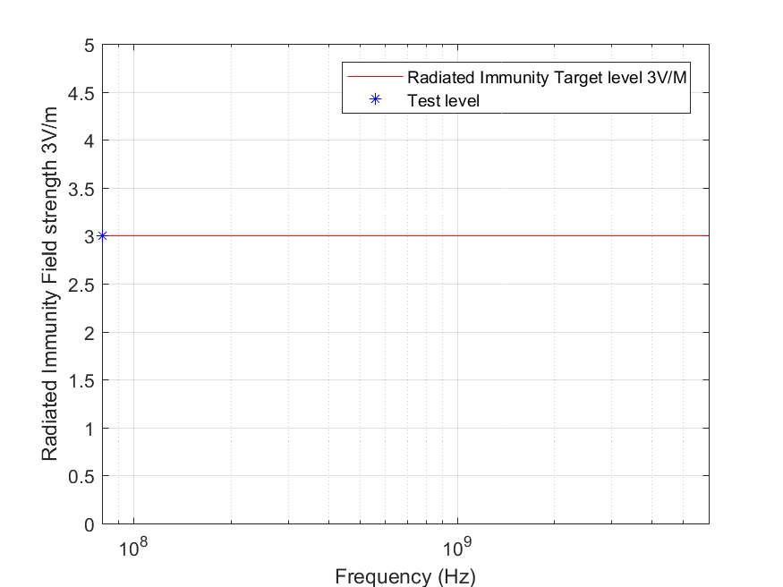

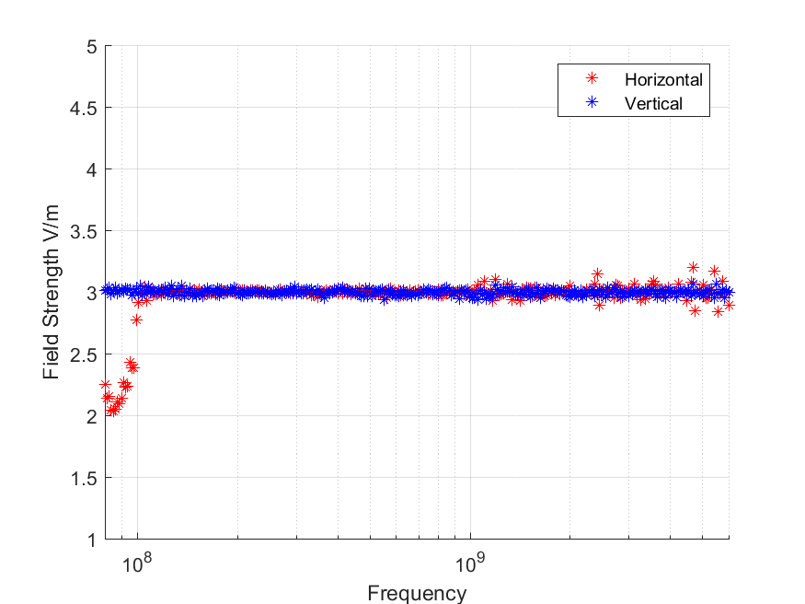

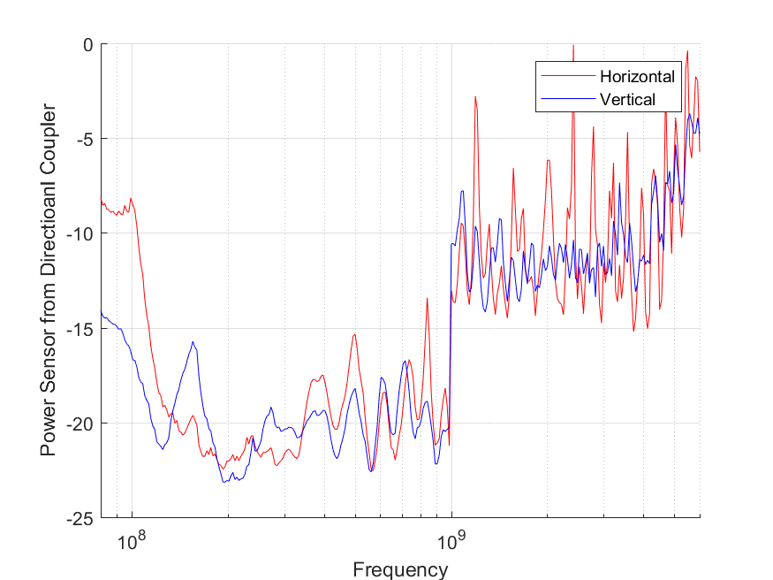

|  |  |  |  |  |
| --- | --- | --- | --- | --- |
| **Criteria:** | | A. Pass - Normal performance within specified limits. | | |
|  | | B. Pass - Temporary degradation, self recoverable. | | |
|  | | C. Pass - Temporary degradation, requires operator intervention. | | |
|  | | D. Fail - Not recoverable, component damage. | | |
|  | |  | | |
|  |  | |  |  |

|  |  |  |  |
| --- | --- | --- | --- |
| Field Uniformity Calibration Data | | | |
|  |  | | |
| Field Uniformity Exceptions: (>6dB) | | | |
|  |  |  |  |
|  | Horizontal Axis | 2107.0 MHz | 8.80 dB |
|  | Horizontal Axis | 5040.0 MHz | 7.13 dB |
|  | Horizontal Axis | 5499.0 MHz | 6.37 dB |
|  | Vertical Axis | None | N/A |
|  |  |  |  |
|  |  |  |  |
|  |  |  |  |
|  |  |  |  |
|  |  |  |  |
|  |  |  |  |
|  |  |  |  |
|  |  |  |  |
|  |  |  |  |

# Summary

The unit passed the Radiated Immunity Emission Test!